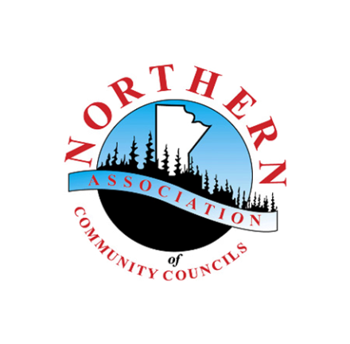
Media (Photo/Video/Audio) Release Form

Organization: Northern Association of Community Councils (NACC),
Northern Healthy Foods Initiative (NHFI) Program
EVENT/PROJECT NAME: .
DATE: __ , 2024

I hereby agree and grant the above organization/group and any person(s) they explicitly authorize, the absolute permission to use and reproduce any pictures/video/audio of myself, or any in which I may appear, to be used for the purposes of publication, display or exhibition thereof for articles, promotions, websites, visual presentations (such as virtual workshops) and without any payment or compensation due to me.
I understand that these photos/videos/media may be used to tell the story of northern Manitoba communities taking action and leading efforts to improve food security, community economic development, youth engagement, or population health.
By signing this Release Form, I confirm that I am over 18 years of age and/or a guardian of the participant. I release the above-mentioned organization/group and the event photographer/ videographer from any liability for any damage, injuries or cases of action that I may incur as a result thereof.
Name (print) ___________________________________________
Community:____________________________________________
Signature: ______________________________________________
Date: __________________________________________________

