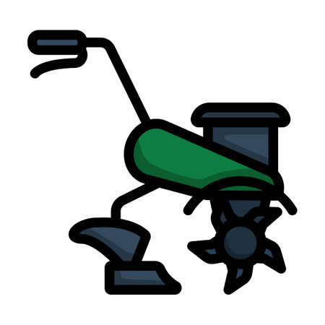
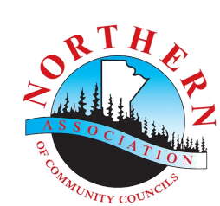
Community Food & Garden

Equipment Program (EP)

If your community is in need of equipment to support a community food project within the Northern Association of Community Councils’ Northern Healthy Foods Initiative Boundary, apply to the NACC Community Food and Garden Equipment Program today:

The community food and/or garden equipment can be used in homes, schools, community food / gardens projects or for workshops with the goal of increasing local food production or supporting safe food handling and preserving skills and knowledge. A local Community Food Champion, community council, school or volunteer must agree to host and report on the equipment use to NACC. Examples include, but are not limited to:
- Garden tiller
- Composter
- Dehydrator
- Pressure Canner

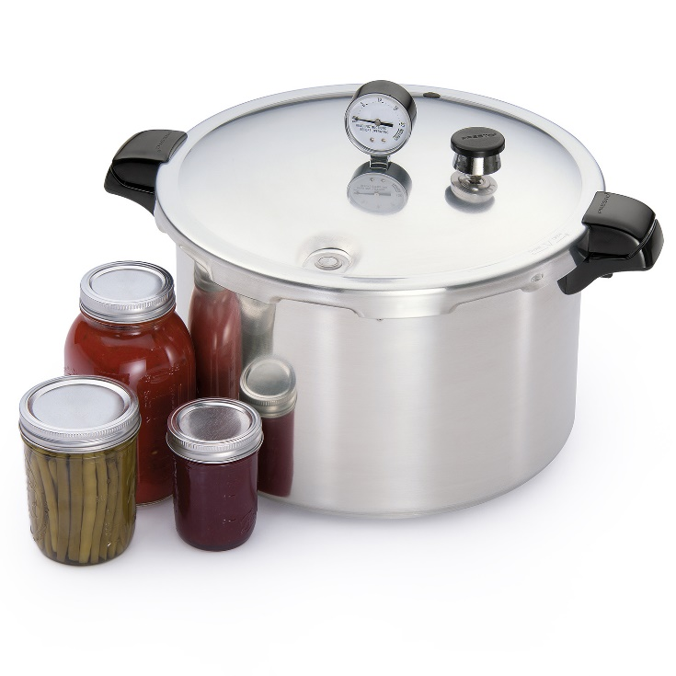
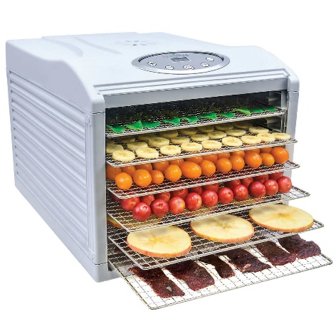

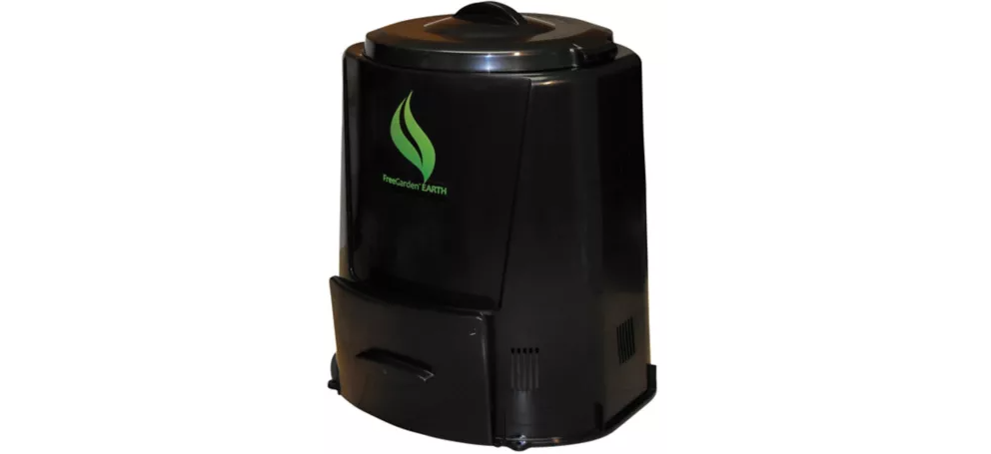

To learn more about the Food & Garden Equipment Program contact:
Nadine Tonn, NHFI Program Coordinator
Northern Association of Community Councils
Ph: 204-947-2227 ex. 2 | Toll Free: 888-947-6222 | Fax: 204-947-9446
Email: programnhfi@naccmanitoba.com
Apply: by May 30th Following deadline, applications will be received on an ongoing basis.
Northern Association of Community Councils
Northern Healthy Foods Initiative
Unit 9 - 395 Berry Street
Winnipeg, MB R3J 1N6
Phone: 1-204-947-2227 Ext. 2
Toll Free: 1-888-947-6222
Fax: 204-947-9446
Email: programnhfi@naccmanitoba.com

Community Food & Garden Equipment (EP) Program – Application / Agreement Form

Applicant Information
Host Full Name: |  |  |  |  |  |  | Date:
Approx.. # of participants (age): under 18_____ 18-30_____ 31-50 _____ 51 – 59 _____ 60+______
Community: |  |  |  |  |  |  | NHFI Eligible: | ? Yes / No
Address:
 | Physical / shipping address
 | Mailing address |  |  |  |  |  |  |  | Apartment/Unit #
 | City/Town/Village |  |  |  |  | Province |  |  | Postal Code
Phone: |  |  |  | Cell | :
Fax: |  |  |  | Email

Community Food & Equipment Program (EP) Community / Participant Agreement
Equipment type:______________________ Purpose: ______________________________
Equipment Year: __________ Make: _____________ Model: ___________ Warranty: _____________ Vendor:________ New or used?: ___________ Stored at: _________ Funded by:__________________
Maintenance Plan: _____________________________ Average use:___________________________
Rationale for equipment:

- Store & carry out EP activities within NACC Northern Healthy Foods Initiative community boundary (community above)
- Follow applicable equipment manuals and maintenance requirements
- Equipment to be used only as noted in application
- Location and use of equipment to be reported to NACC through the Community Annual Report
- Contact NACC if you are moving or no longer wish participate in program while in hosting an EP item
- Ensure the technical and safety requirements of the equipment are followed and adhered to.
- Provide suitable operation of equipment per manufacture recommendations.
- Contact NACC regarding any EP issues or difficulties as they occur
- Attend required EP training made available
- Complete program surveys, reports and submit photos
Signature: ___________________ Date:__________________________
PLEASE SIGN and return to NACC. RETAIN A COPY FOR YOUR RECORDS
Applications will be reviewed on a first come first serve basis. If your application meets the requirements, you will be sent a welcome package and instructions. Should your application be received after program is exhausted, you will be placed on a waiting list.

