****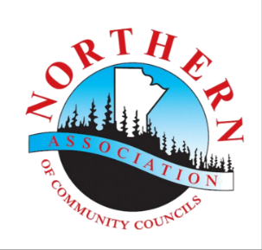

**Safe at Home Workshops – Registration Form**

Community: _____________________________

*Please submit this* **Registration Form by** *____________________*

*to:*

*____________________*

*____________________*

Phone: _______________________

✔ Select the information and kits you and/or your family are interested in learning about or trying while safe at home.

|  |  |
| --- | --- |
| **Information** | **Workshop Kits** |
| * Beekeeping | * Community Trapping Kit |
| Gardening   * Alex’s First Seed Story (K-2) * Cold Climate Gardens * Fruit Crops * Garden Planning * Greenhouses * Growing Potatoes * The Three Sisters * Soil Module Booklet | Crafting:   * Card Making * Colouring Kit (Adult) * Colouring Kit (Kids) * Moccasin/Leather/Bead Making Kit * Scrap Booking * Sewing |
| * Journal/Diary |
| Food Preservation   * Smoking * Dehydration * Canning | Painting Kit:   * Acrylic * Garden Decoration * Water Colours |
| * Medicinal Plants | Fishing Kits:   * Fishing Kit (Adult) * Fishing Kit (Kids) * Fishing License Subsidy |
| * Seed Saving |
| Kitchen   * Commercial Kitchen * Getting Your Food to Market * Working with Youth in the Kitchen | Recipe Kit:   * ____________________ |
| * Ice Fishing Kit |
| * Seed Starting Kit |
| Livestock   * Broiler Chickens * Laying Hen Care * Meat Goats * Rabbits | * Cheese Making Kit |
| * Window Herb Garden Kit |
| * Vermicompost: Worms & Bin |

Special requests:(Examples: recipes, books, maple tapping, carving kits)  
_____________________________________________________

Name(s): *List all participants in household* ___________________________________

___________________________________

___________________________________

___________________________________

Mailing Address: ___________________________________

___________________________________

Postal Code: _________________________  
  
Phone Number: ______________________  
  
Email Address: _______________________  
  
By signing below I agree to complete a feedback form and share photos of my experience.

By signing below, I hereby agree to and give permission for the use of the photographs taken of me for the purposes of publication, display or exhibition thereof for articles, promotions, websites and visual presentations and without payment or compensation to me.

I understand that these photos may be used to tell the story of northern Manitoba communities taking action and leading efforts to improve food security, community economic development, youth engagement, or population health.

Signature: ______________________________

Date: __________________________________

Kits filled on a first-come-first-serve basis while quantities last.